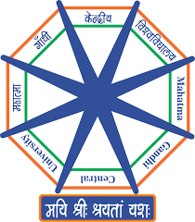
महात्मा गाँधी केन्द्रीय विश्वविद्यालय

Mahatma Gandhi Central University, Bihar
A Central University established by an Act of Parliament

Atal Bihari Vajpayee Central Library
(Please fill all details in capital letters)
(Student Membership Form)

Name ……………………………………………………………….. Date of Birth……………………………………………
Father’s name………………………………………………………..................................................................
Program ……………………………………………………. Enrolment No. ………………………………………………….
ABC ID ………………………………………………………… Session ………………………………………………………..

Department …………………………………………………… School …………………………………………………………

Email ID ………………………………………………………………………….. Gender ………………………………………

Contact No. …………………………………………………………………………….. Blood Group………………………
Address ………………………………………………………………………………………………………………

……………………………………………………………………………………………………………………………………………..

Student’s Signature HOD / Dean (Signature with Stamp)


Please scan here to fill this also.

For Library Use Only
Membership Page No………………… Assistant Librarian (I/C) Card Entry [ ]
Card Print [ ]

Librarian (I/C)

